**Difference between File System and DBMS**

**File System**

File system is basically a way of arranging the files in a storage medium like hard disk. File system organizes the files and helps in retrieval of files when they are required. File systems consists of different files which are grouped into directories. The directories further contain other folders and files. File system performs basic operations like management, file naming, giving access rules etc.

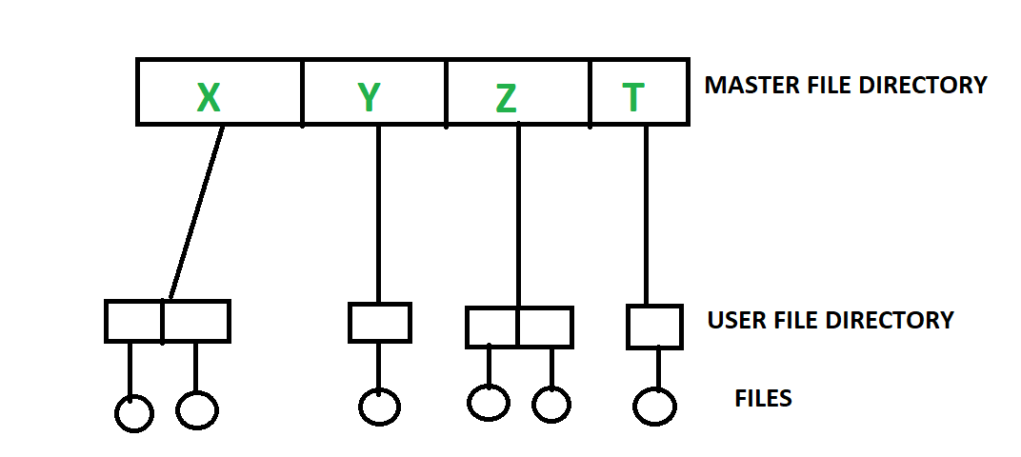

**DBMS (Database Management System)**

Database Management System is basically a software that manages the collection of related data. It is used for storing data and retrieving the data effectively when it is needed. It also provides proper security measures for protecting the data from unauthorized access. In Database Management System the data can be fetched by SQL queries and relational algebra. It also provides mechanisms for data recovery and data backup.

Example:

Oracle, MySQL, MS SQL server.

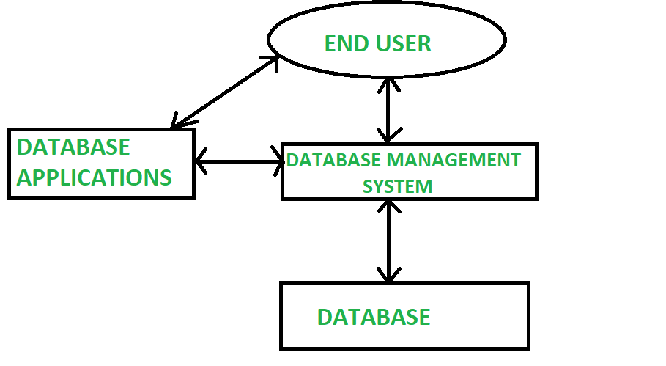

Difference between File System and DBMS :

|  |  |  |
| --- | --- | --- |
| S.NO. | FILE SYSTEM | DBMS |
| 1. | File system is a software that manages and organizes the files in a storage medium within a computer. | DBMS is a software for managing the database. |
| 2. | Redundant data can be present in a file system. | In DBMS there is no redundant data. |
| 3. | It doesn’t provide backup and recovery of data if it is lost. | It provides backup and recovery of data even if it is lost. |
| 4. | There is no efficient query processing in file system. | Efficient query processing is there in DBMS. |
| 5. | There is less data consistency in file system. | There is more data consistency because of the process of normalization. |
| 6. | It is less complex as compared to DBMS. | It has more complexity in handling as compared to file system. |
| 7. | File systems provide less security in comparison to DBMS. | DBMS has more security mechanisms as compared to file system. |
| 8. | It is less expensive than DBMS. | It has a comparatively higher cost than a file system. |